**1. A Kısmı – 1. Şık**

clc  
clear  
close all  
  
load 'handel.mat'  
x = y;  
N = length(x);  
w = fftshift(fft(x))/N;  
f = -pi : 2*pi/N : pi - 2*pi/N;  
figure();  
stem(f,w);  
title('Fourier Transform of Original Signal');  
xlabel('Frequency');  
ylabel('Amplitude');

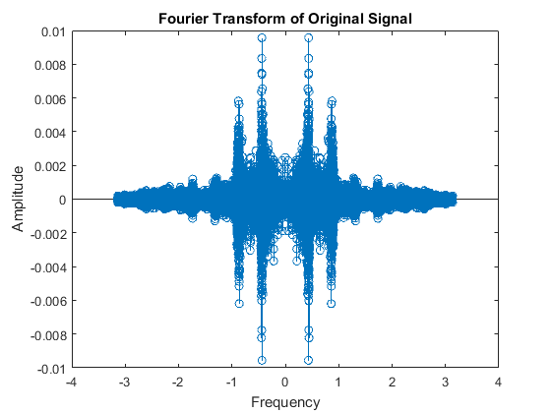

**2. A Kısmı – 2. Şık**

L1 = 3;  
NL1 = L1 * length(x);  
f1 = Fs*L1;  
  
r1 = zeros(1,NL1);  
r1(1:L1:end) = x;  
Wr1 = fftshift(fft(r1,NL1))/NL1;  
fr1 = -pi : 2*pi/NL1 : pi - 2*pi/NL1;  
  
figure();  
stem(fr1,Wr1);  
title('Fourier Transform of r1[n]');  
xlabel('Frequency');  
ylabel('Amplitude');

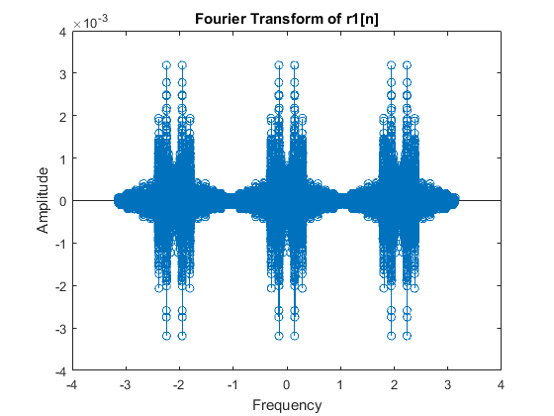

**3. B Kısmı**

Sesin dinlenmesini sonucunda, up-sampling ve linear interpolasyon filtresi uygulanmasın sinyalin daha iyi sonuç verdiği görülmüştür.

**4. C Kısmı**

L2 = 3;  
NL2 = L2*length(x);  
f2 = Fs*L2;  
  
r2 = zeros(1,NL2);  
r2(1:L2:end) = x;  
Wr2 = fftshift(fft(r2,NL2))/NL2;  
fr2 = -pi : 2*pi/NL2 : pi - 2*pi/NL2;  
  
figure();  
stem(fr2,Wr2);  
title('Fourier Transform of r2[n](After Up-Sampling)');  
xlabel('Frequency');  
ylabel('Amplitude');  
  
hlinear = [1/3 2/3 1 2/3 1/3];  
r22 = conv(r2,hlinear);  
  
NLh = length(r22);  
Wr22 = fftshift(fft(r22,NLh))/NLh;  
fr22 = -pi : 2*pi/NLh : pi - 2*pi/NLh;  
  
figure();  
stem(fr22,Wr22);  
title('Fourier Transform of r2[n](After Interpolation Filter)');  
xlabel('Frequency');  
ylabel('Amplitude')

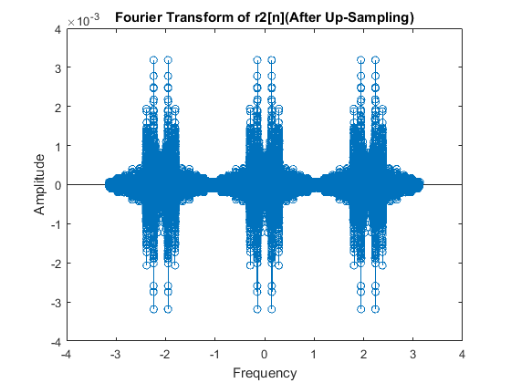

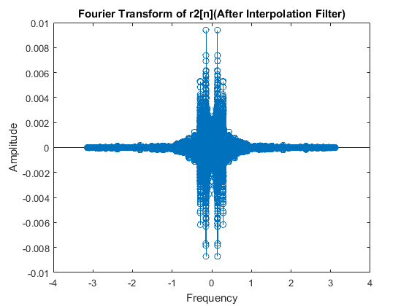

**5. E Kısmı**

M = 2;  
x_best = r22;  
Fdown = f2/M;  
Nm = length(x_best)/M;  
  
y_down = x_best(1:M:end);  
Wy = fftshift(fft(y_down,Nm))/Nm;  
fy = -pi : 2*pi/Nm : pi -2*pi/Nm;  
  
figure();  
stem(fy,Wy);  
title('Fourier Transform of y[n]');  
xlabel('Frequency');  
ylabel('Amplitude');  
sound(y_down,Fdown);

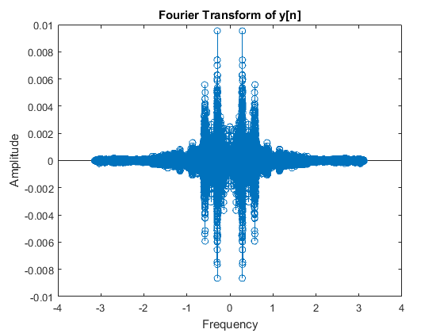

display(' x(n) r2(n) y(m)');  
display('fs 8192 24576 6144');  
display('N 73113 219343 109672');  
display('The parameters are gotten from WorkSpace.')